House Price Prediction using Regression-based Machine Learning

Project Id: AIML-5

Name : Avika Grover (Team Leader)
Class Roll Number: 36
University Roll Number : 2028681
Section and Group: U (G2)

Name : Divya Singh
Class Roll Number: 39
University Roll Number : 2028712
Section and Group: U (G2)

Name : Rakshita
Class Roll Number: 55
University Roll Number : 2028817
Section and Group: U (G2)

TABLE OF CONTENTS

- Problem Description 3
- Architecture 4
- Models model 5
- Evaluation metrics used 6
- Preliminary Results and Visualizations 7
- References 10

- Problem Description

The House Price Prediction System is designed to estimate residential property prices using a structured dataset containing 25 different property-related features. These features include both numerical and categorical variables such as property area, number of bedrooms and bathrooms, number of floors, year built, property age, lot size, and several location-based factors like distance from city center, neighborhood quality, and crime rate.

In addition to physical and location attributes, the dataset also considers modern factors like construction quality, energy efficiency, availability of parking, internet access, reliability of utilities, and environmental indicators such as noise pollution, flood risk, and green space availability. All these features together play an important role in determining the final price of a house.

The main aim of this project is to build a reliable machine learning model that can predict house prices more accurately than traditional estimation methods. The system follows a complete pipeline starting from raw data analysis to final prediction and evaluation.

Initially, Exploratory Data Analysis (EDA) is performed to understand the structure of the dataset, identify missing values, detect outliers, and study relationships between features and the target variable (house price). After this, data preprocessing steps such as handling missing values, encoding categorical features, and scaling numerical values are applied to prepare the dataset for model training.

Multiple regression algorithms are then implemented, and their performance is compared to select the best model. The final output of the system includes predicted prices along with performance evaluation and visual analysis.

- Architecture

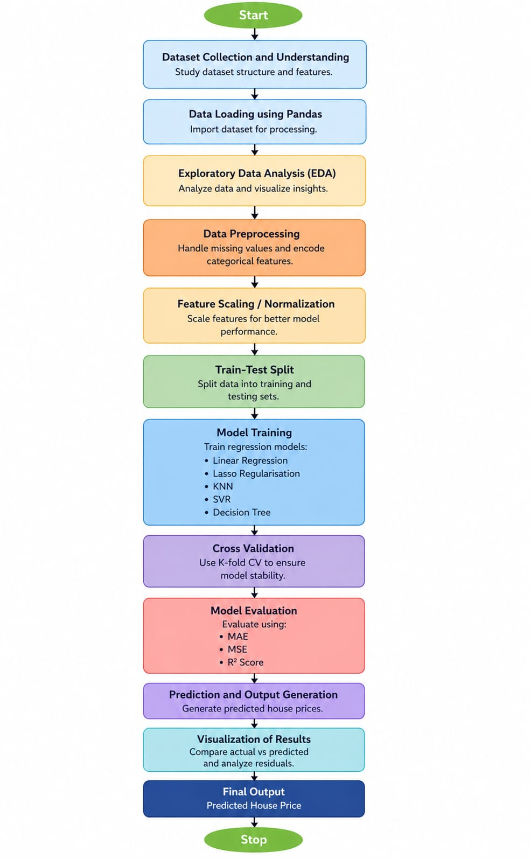

Fig.1 Flow diagram.
- Models Used (Applied/ Planned)
1. Linear Regression -

Linear Regression is the simplest regression technique used in this project. It assumes a linear relationship between input features and house price. The model tries to fit a straight-line equation that minimizes the error between actual and predicted values. It is used as a baseline model to compare the performance of other algorithms.

2. Lasso Regression -

Lasso Regression is an extension of linear regression that includes L1 regularization. It helps in reducing overfitting by penalizing large coefficients. One key advantage of Lasso is that it can shrink some coefficients to zero, effectively performing feature selection and improving model interpretability.

3. K-Nearest Neighbors (KNN) Regressor -

KNN Regressor predicts house prices based on similarity between data points. It finds the nearest ‘k’ neighbors using distance metrics and calculates the average of their values. This model works well when similar properties have similar prices but requires proper scaling of features for better performance.

4. Decision Tree Regressor -

Decision Tree Regressor splits the dataset into smaller subsets based on feature conditions. It forms a tree-like structure where each node represents a decision rule. This model can capture complex and non-linear relationships between features and house prices but may overfit if not controlled properly.

5. Support Vector Regressor (SVR) -

SVR is a powerful regression algorithm that tries to fit data within a certain margin of error. Instead of minimizing absolute error, it focuses on maintaining a boundary within which predictions are acceptable. It performs well on high-dimensional data but requires feature scaling and careful parameter tuning.

6. Cross Validation -

Cross validation is used to test how well a model generalizes to unseen data. In this project, k-fold cross validation is applied, where the dataset is divided into multiple parts and the model is trained and tested multiple times. The final score is the average of all iterations, giving a more reliable evaluation.

- Evaluation metrics used

1. R² Score -

R² score indicates how much variation in house prices is explained by the model. A value closer to 1 means better prediction capability.

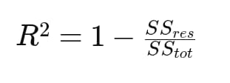

2. Mean Absolute Error (MAE) -

MAE measures the average absolute difference between actual and predicted prices. It gives a clear idea of how far predictions are from real values.

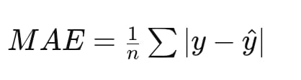

3. Mean Squared Error (MSE) -

MSE calculates the average squared difference between actual and predicted values. It penalizes larger errors more heavily, making it useful for detecting significant prediction mistakes.

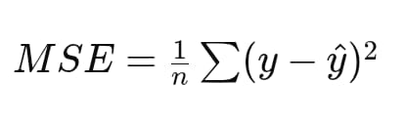

4. Root Mean Squared Error (RMSE) -

RMSE is the square root of MSE and provides error in the same unit as the target variable, making it easier to interpret.

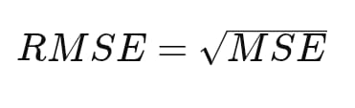

5. Preliminary Results and Visualizations

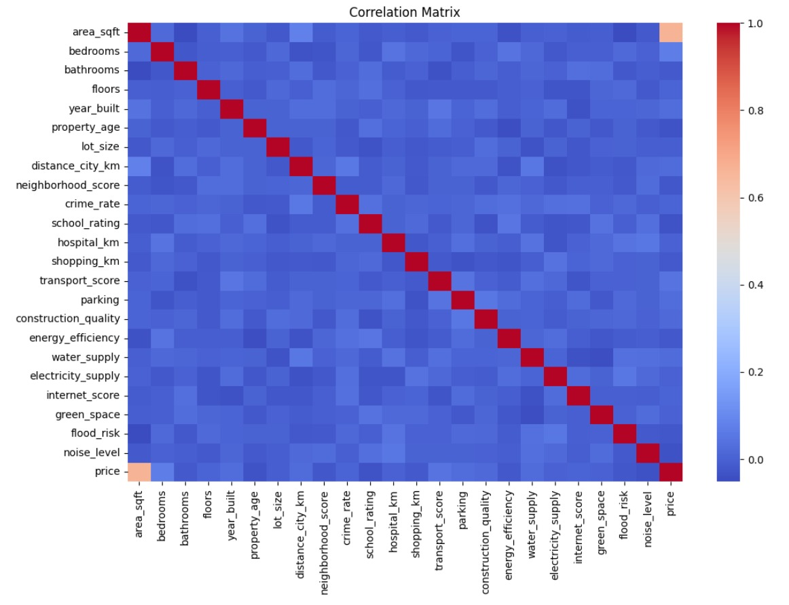

Fig.2 Heatmap showing corelation.

Inference : The correlation matrix indicates that area_sqft has the strongest positive correlation with price, making it the most significant predictor in the dataset. Most other features show weak or negligible linear relationships with each other, suggesting low multicollinearity among the remaining variables.

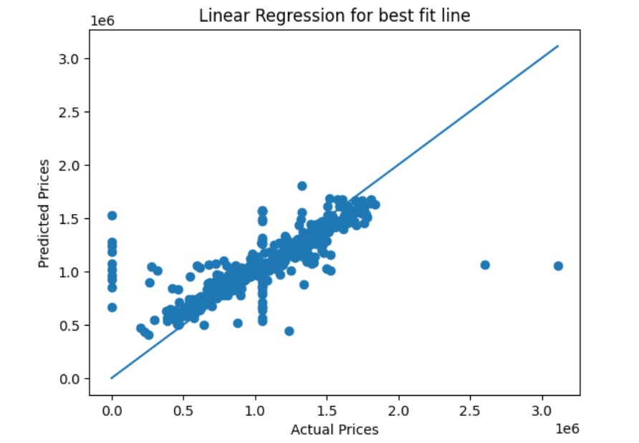

Fig.3 Actual vs Predicted (Best fit line)

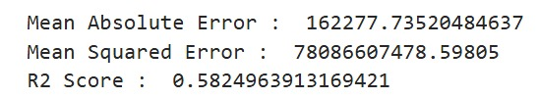

Inference : The residuals are mostly centered around zero, which shows the model captures the main data trend fairly well. However, the wide scatter and extreme outliers at higher values suggest it struggles with accuracy for more expensive properties.

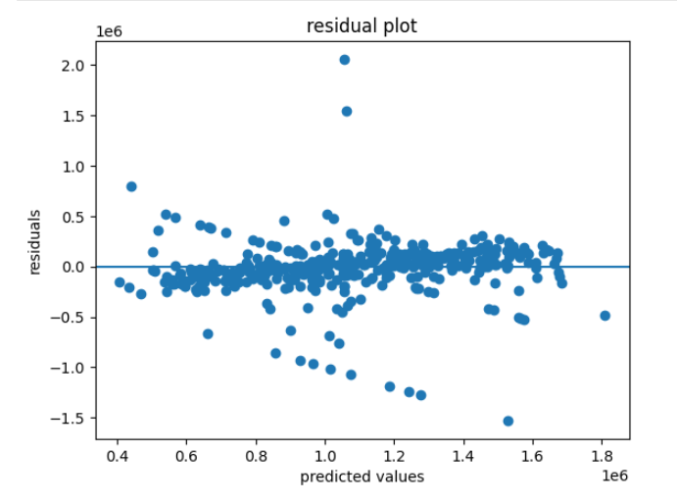

Fig.4 Residual plot

Inference : The plot shows a strong linear relationship where predictions closely follow the actual values, indicating a well-performing model. However, several significant outliers at the extreme ends of the price range suggest the model struggles with very low or very high-value propertie

6. References:
Books:
- Hands-On Machine Learning with Scikit-Learn, Keras and TensorFlow
- Python for Data Analysis by Wes McKinney

Online Resources:
- Scikit-learn Documentation
- Kaggle Datasets
- GeeksforGeeks
- Stack Overflow

